**CP Club 365Days Challenge**

**Programming language – C++**

**Problem Statement**

[https://practice.geeksforgeeks.org/problems/check-if-string-is-rotated-by-two-places-1587115620/1?page=1&difficulty[]=0&category[]=Strings&sortBy=submissions](https://practice.geeksforgeeks.org/problems/check-if-string-is-rotated-by-two-places-1587115620/1?page=1&difficulty%5b%5d=0&category%5b%5d=Strings&sortBy=submissions)

**Your Code**:

// 0x58Day of 0x365Days challenge

// VEDANT BHARAD

// 14-12-2022

//{ Driver Code Starts

#include <bits/stdc++.h>

using namespace std;

// } Driver Code Ends

class Solution

{

    public:

    //Function to check if a string can be obtained by rotating

    //another string by exactly 2 places.

    bool isRotated(string str1, string str2)

    {

        if(str1.length()==1 && str2.length()==1)

        {

            if(str1==str2) return true;

            else return false;

        }

        else{

            string rotatedleft,rotatedright;

            //1

            // rotatedleft.append(str1.substr(2,str1.length()-2));

            // rotatedleft.append(str1.substr(0,2));

            // rotatedright.append(str1.substr(str1.length()-2,2));

            // rotatedright.append(str1.substr(0,str1.length()-2));

            //

            //2

            for(int loop=2;loop<str1.length();loop++)

            {

                rotatedleft.append(1,str1[loop]);

            }

            rotatedleft.append(1,str1[0]);rotatedleft.append(1,str1[1]);

            rotatedright.append(1,str1[str1.length()-2]);rotatedright.append(1,str1[str1.length()-1]);

            for(int loop=0;loop<str1.length()-2;loop++)

            {

                rotatedright.append(1,str1[loop]);

            }

            //

            if(rotatedright==str2 || rotatedleft==str2)

            {

                return true;

            }

            else return false;

        }

    }

};

//{ Driver Code Starts.

int main() {

    int t;

    cin>>t;

    while(t--)

    {

        string s;

        string b;

        cin>>s>>b;

        Solution obj;

        cout<<obj.isRotated(s,b)<<endl;

    }

    return 0;

}

// } Driver Code Ends

**Output (Screen Shot)**:

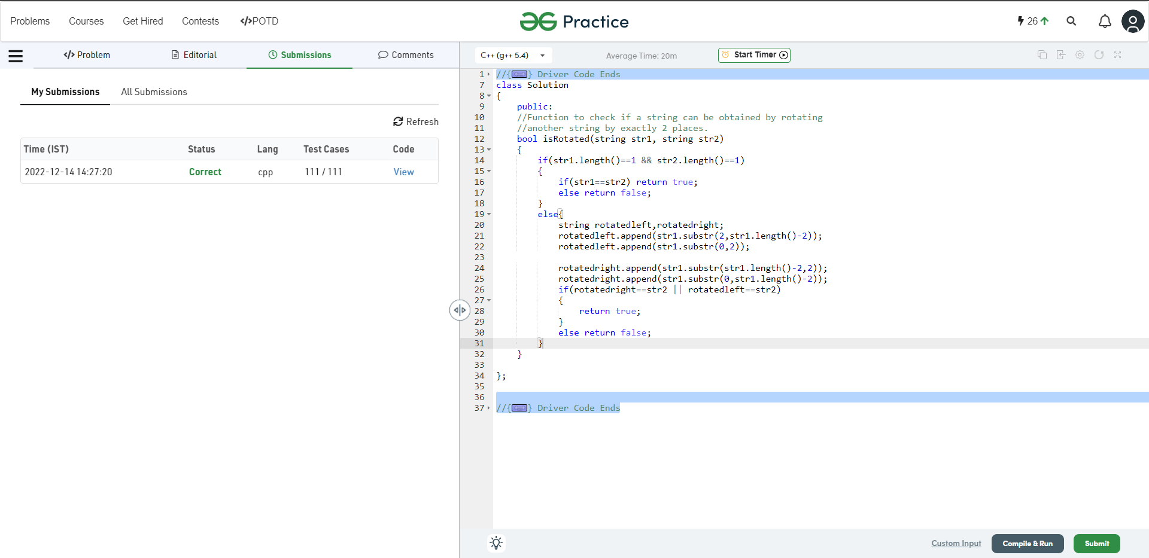

**Understanding about problem:**

* In this task I need to return true of false,after rotation string 1 clockwise and anticlockwise if the Rotated string is equal to string 2 then return true else false.

Note: If you can't understand the problem, feel free to contact us and we'll help you. Please don't copy and paste from anywhere.

ALL THE BEST

Team CP Club